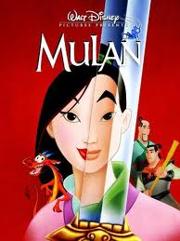 Name_________________________________________
Mulan Writing Assignment
Using your notes, text, and the internet please answer the following questions in essay form; (Minimum of 3 Paragraphs)
This will be a QUIZ GRADE.
- How does the movie “MULAN” reflect traditional Chinese views of women and their role in and value to society during the Ming and Qing Dynasties? Please give specific examples from the movie.

- How does the character of Mulan fill the role of traditional Chinese woman and how does she break from this role? Again please be specific.

Mulan Writing Assignment Rubric
Name____________________________________________
- Is the length of the essay at least three paragraphs? ___________ out of 25

- Did you use specific examples from the movie? ____________ out of 25

- Are the questions answered completely? ____________ out of 50

- Did you answer both questions?
- Did you use complete sentences?
- Did you use proper grammar? Total Points ____________

